What’s in Ned’s head  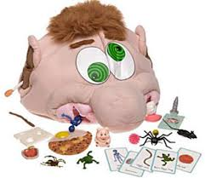  Intermediate level  Ages: 3rd-7th grade | Pieces included in visuals  Rules for game  - Set a timer or play until all the cards are used  - Students take turns drawing a card from the pile  - Once they pick a card, they can share with the group using the visual cues  - Have the student place their hand in “Ned’s head” and find the object  - Have the peers in the group tell the student “try again” if he picks the wrong item out of the head or other students can help the student out by looking in the head and guiding them to the object  - Once the student has the object the other student can ask the student “What did you get?”  - Place the item back into head after each students’ turn  Additional Tips and Ideas  - Create new cards with additional items based on the student interests or skills needed (great game for teaching adjectives)  - Encourage students to look at the items and talk about them asking various “WH” questions such as “When could you use this?” “Where do you find this?”

